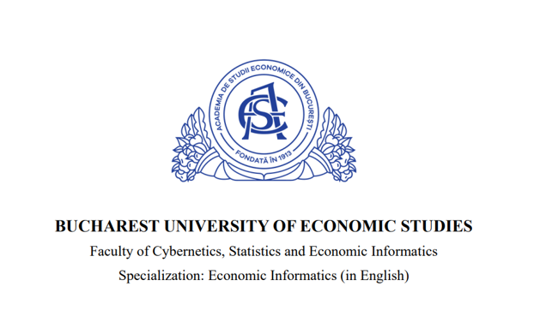

Aggregated Report on the Impact of COVID-19 on Student Life and Education in Delhi, India

Tănasie Alexia-Ștefania

Bucharest
2025
Data Source
The dataset we chose for the project is from Kaggle, and it can be accessed using this link.
Time reference on dates
The data was collected during 2020 in order to explore the impact of Covid Pandemic on students in New Delhi.
Description of the variables
The variables of this dataset are factors that determine if there was or not any impactt on the social life or health during Covid Pandemic.

- ID (identifier for the respondent)
- Region of residence (geographic location of the respondent)
- Age of Subject (age of the respondent in years)
- Time spent on Online Class (hours spent daily attending online classes)
- Rating of Online Class experience (evaluation of the quality of the online class experience)
- Medium for online class(device or platform used to access online classes)
- Time spent on self-study(hours spent daily on independent academic study)
- Time spent on fitness(hours spent daily on physical exercise or fitness activities)
- Time spent on sleep: average number of hours of sleep per day
- Time spent on social media(hours spent daily using social media platforms)
- Preferred social media platform(most frequently used social media platform)
- Time spent on TV(hours spent daily watching television)
- Number of meals per day(number of meals consumed daily)
- Change in your weight (any weight change experienced during the specified period)
- Health issue during lockdown(indicates the presence of health issues during the specified period)
- Time utilized (whether the time during the specified period was perceived as effectively utilized)
- Do you find yourself more connected with your family, close friends, relatives?(whether a closer connection with family, friends, and relatives was felt during the specified period)

Description of observations
The dataset used in this study was derived from a cross-sectional survey conducted in 2020. It includes responses from a sample of 1,182 students belonging to various age groups and studying in diverse educational institutions located within the Capital Delhi.
The data captures a broad spectrum of variables, providing insights into students' preferences, behavior and experiences during Covid to show if there was any impact on their social life, education and mental health.

Methodology and Tools Used
Python was used for data processing, aggregation, and visualization. The Pandas library enabled efficient manipulation of tabular data, including grouping by age categories and calculating average values. Matplotlib and Seaborn were chosen for data visualization, as they provide clean and informative charts suitable for identifying trends and differences across groups. Key functions such as groupby(), mean() and value_counts() were applied to generate aggregated reports on student behavior during the lockdown. Charts like the boxplot (for sleep distribution) and the stacked bar chart (for health issues) were selected to highlight variability and comparative proportions in a visual and interpretable manner. These tools and techniques were chosen to ensure clarity, accuracy and accessibility in presenting the data-driven insights.

Results and Interpretations
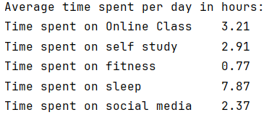
Most students maintained a balanced daily routine with sufficient sleep ~8 hrs. However, physical activity was significantly low. Social media usage ~2.4 hrs/day suggests a moderate level of digital engagement, likely used to cope with isolation.

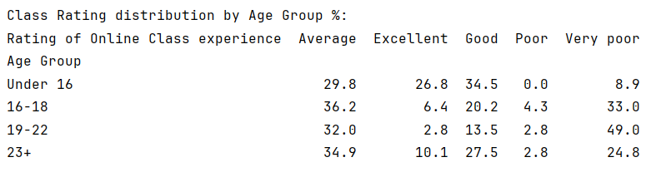
Younger students were generally more satisfied with online learning. Students aged 19–22 were the least satisfied – nearly half rated the experience as “Very Poor,” suggesting challenges like academic stress and lack of interactive content.

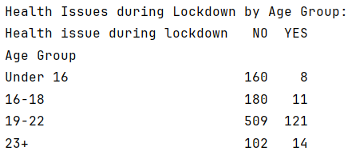
The 19–22 age group reported the most health problems, potentially due to academic pressure and social isolation. Younger students were more resilient, with fewer reported health concerns.

Correlation between social media use and online class rating: -0.14
There's a weak negative correlation between social media time and online class satisfaction. This suggests that students who spend more time on social media may be slightly less satisfied with their academic experience, possibly due to distraction or emotional strain.

Visualizations
Boxplot – Sleep time by age group
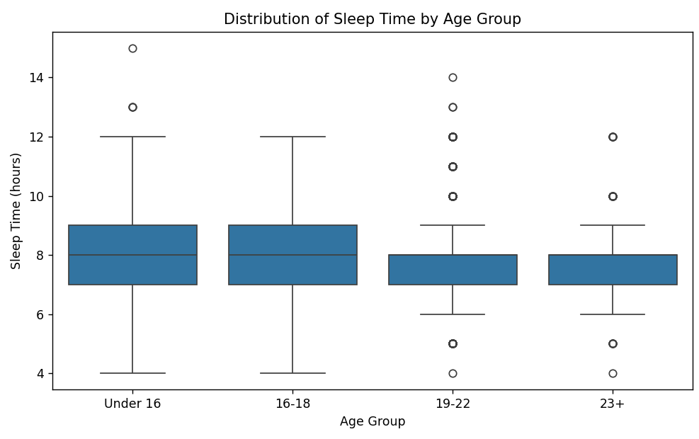The boxplot shows that the median sleep time across all age groups is around 8 hours, which is generally healthy. However, students aged 19–22 show more irregular sleep patterns, with a higher number of outliers — both short and excessive sleep durations. This may reflect stress, academic pressure, or disrupted routines. Younger students (Under 16 and 16–18) tend to have more consistent sleep habits, possibly due to parental guidance and lighter workloads. Overall, while average sleep is sufficient, the variability among older students suggests potential mental or physical health concerns.

Stacked Bar Chart – Health issues by age group
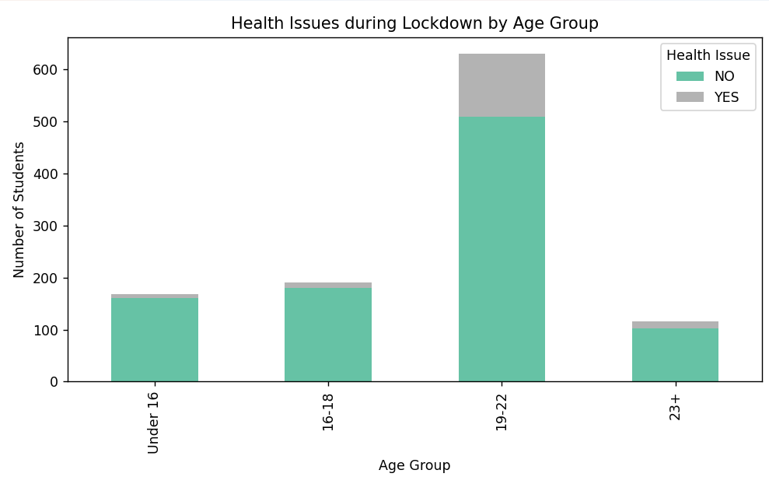
The chart reveals that students aged 19–22 experienced significantly more health issues during the lockdown compared to other age groups. This group not only had the largest total number of respondents but also the highest proportion reporting health concerns. In contrast, students under 16 and those aged 16–18 reported very few health issues, suggesting they may have been less affected physically or mentally. The findings indicate that young adults faced greater challenges, potentially due to academic stress, isolation, or lifestyle changes during the pandemic.
Conclusion
The analysis shows that while students overall maintained relatively healthy routines, certain groups (especially aged 19–22) experienced more dissatisfaction with online education and reported more health issues. Social media use was moderate, but slightly negatively correlated with academic satisfaction. These insights highlight the need for better mental health support and improved online learning tools for older students.

